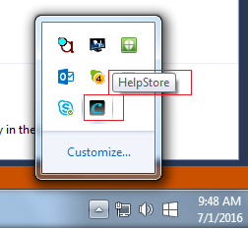

1. Drag a **NotifyIcon** control onto the form. The control will named **notifyIcon1** by default and placed below the form because it has no visual representation on the form itself.
2. Set the **NotifyIcon** control's **Text** property, in this case "HelpStore".
3. Set the control's **Icon** property to the icon that you want to appear in the System Tray.

**Tip:** If you have a BMP file that you want to convert to an icon file, I highly recommend the [QTam Bitmap to Icon 3.5 application](http://www.qtam-computer.com/download.shtml).

1. Add an event handler for the form's **Resize** event that will hide the application when it's minimized. That way, it won't appear on the task bar.

private void Form1_Resize(object sender, System.EventArgs e)

{

**if (FormWindowState.Minimized == WindowState)**

**Hide();**

}

1. Add an event handler for the **NotifyIcon.DoubleClick** event.

private void notifyIcon1_DoubleClick(object sender, System.EventArgs e)

{

**Show();**

**WindowState = FormWindowState.Normal;**

}